📚 DocuSense: Advanced Self-Correcting RAG Architecture
1. Project Overview & Focus
What is it? DocuSense is an enterprise-grade Retrieval-Augmented Generation (RAG) system built to answer complex software engineering questions by querying open-source documentation.
What does it focus on? Naive RAG systems (simple PDF chatbots) fail in technical domains because they lose exact variable names in vector space and hallucinate when users ask vague questions. DocuSense focuses on accuracy, self-correction, and verifiability. It implements advanced methodologies—Hybrid Search, Multi-Query Expansion, and Corrective RAG (CRAG)—to ensure that every answer is grounded in exact documentation and strictly cited.
2. System Architecture
The pipeline is divided into two distinct phases: Ingestion (Offline) and Retrieval/Generation (Online).
Phase 1: Data Ingestion & Indexing
- Web Scraping & Extraction: Downloads raw .zip files of GitHub repositories (FastAPI, LangChain, Scikit-Learn, PyTorch, TensorFlow) and extracts targeted .md and .rst documentation.
- Cleaning & Chunking: Strips HTML/Markdown artifacts and splits the text using RecursiveCharacterTextSplitter (1000 characters with 200 overlap) to maintain contextual boundaries.
- Dual Indexing:
  - Vector Store (ChromaDB): Embeds chunks into dense vectors using sentence-transformers (all-MiniLM-L6-v2) to capture semantic meaning.
  - Keyword Store (Rank-BM25): Tokenizes chunks into a sparse index to capture exact keyword matches (e.g., specific Python class names).
Phase 2: Online Retrieval & Generation (The CRAG Pipeline)
- Multi-Query Generation: A user submits a query. An LLM (Nemotron-120B) generates 3-4 technical variants of the query to broaden the search scope.
- Parallel Hybrid Retrieval: The system queries both ChromaDB and BM25 simultaneously across multiple threads for all query variants.
- Reciprocal Rank Fusion (RRF): The results from the Vector and Keyword searches are mathematically fused and ranked to provide the top most relevant chunks.
- Corrective RAG (CRAG) Evaluation: An "LLM-as-a-Judge" evaluates the retrieved chunks.
  - If the context is relevant, it proceeds to generation.
  - If the context is irrelevant or the query is too vague, the LLM rewrites the query using proper engineering terminology and loops back to Step 2.
- Answer Generation: The LLM synthesizes the final context into an answer, strictly citing the source file paths using inline brackets (e.g., [1]).
3. Engineering Challenges & Solutions
🔴 Challenge 1: Vector Search Missing Code Syntax
- Issue: Semantic vector search is great for meaning but terrible for exact syntax. Searching for GridSearchCV might return documents about general hyperparameter tuning but miss the exact class documentation.
- Solution: Implemented Hybrid Search. I added a Rank-BM25 sparse index to match exact keywords and used Reciprocal Rank Fusion (RRF) to combine the semantic scores with the keyword scores.
🔴 Challenge 2: LLM Hallucinations on Vague Queries
- Issue: If a user asked, "How do I make the bot remember things?", standard RAG retrieved garbage context, forcing the LLM to hallucinate an answer.
- Solution: Integrated a Corrective RAG (CRAG) layer. I built a RelevanceScorer that grades the context. If it fails, an LLM rewrites "remember things" into "Conversational memory and message history," re-triggering the search to get the right context.
🔴 Challenge 3: High Latency in Multi-Query Retrieval
- Issue: Generating 4 query variants and running Hybrid Search sequentially took upwards of 90 seconds.
- Solution: I overhauled the architecture to use Concurrent Threading (ThreadPoolExecutor). By executing the database queries in parallel, execution time plummeted by 70%, bringing latency down to ~20 seconds.
🔴 Challenge 4: Deploying Massive Artifacts & Environment Crashes
- Issue: GitHub blocked the push of a 277MB ChromaDB SQLite file. Furthermore, Streamlit Cloud crashed during deployment while trying to compile C++ dependencies for Python 3.14.
- Solution: Utilized Git LFS (Large File Storage) to decouple the massive database files from the standard Git tree. For the environment, I created a packages.txt for OS-level dependencies (like zlib1g-dev) and downgraded the environment to a stable Python 3.11 build.
4. Codebase Deep Dive: Explain Like I'm 5
Here is a breakdown of what every file in the src/ directory actually does:
- config.py (The Control Center): Holds all the hardcoded paths, API keys, and model names. If we ever want to swap from NVIDIA to OpenAI, or change the chunk size, we only have to change it here.
- ingest_data.py (The Harvester): Downloads raw docs from GitHub, cleans out the HTML garbage, chops the text into 1,000-character blocks, and saves them as neat JSON files.
- build_index.py (The Librarian): Takes those JSON files and builds the two databases: ChromaDB (for meaning) and BM25 (for exact words).
- vector_store.py & keyword_store.py (The Filing Cabinets): Wrapper classes that make it easy for the rest of the app to add data or search the ChromaDB and BM25 databases.
- hybrid.py (The Matchmaker): Takes the results from the Vector Store and the Keyword Store, applies a math formula (Reciprocal Rank Fusion), and merges them into one master list of best results.
- multi_query.py (The Translator): Uses an LLM to look at a user's dumb question and generate 3 smart, technical ways to ask the same thing. It then searches the databases for all of them in parallel.
- scorer.py & crag.py (The Judge & The Manager): The Judge looks at the retrieved documents and says "Yes, this answers the question" or "No, this is useless." If it says No, the Manager rewrites the question and starts the search over.
- generator.py (The Writer): Takes the final, approved documents and writes the actual answer for the user, making sure to cite the file paths.
- pipeline.py (The Conductor): The main script that glues all the above pieces together in the correct order.
- streamlit_app.py (The Face): The frontend UI that gives the user a text box and buttons to interact with the Conductor.
5. Interview Preparation: Expected Questions & Answers
If you put this on your resume, interviewers will ask you about it. Here is how you answer them:
Interviewer: "I see you used Hybrid Search. Why didn't you just use ChromaDB and standard vector embeddings?"
You: "Semantic vector search is amazing for conceptual matching, but it struggles with exact lexical matches—like specific variable names, API endpoints, or error codes. Because DocuSense reads software documentation, exact syntax is critical. I implemented a Rank-BM25 keyword index alongside ChromaDB and fused their results using Reciprocal Rank Fusion (RRF). This guaranteed that if a user searched for a specific Python class, the keyword index would catch it even if the vector index missed the semantic connection."
Interviewer: "Explain what Corrective RAG (CRAG) is and why you needed it."
You: "Standard RAG assumes the retrieved context is always good. If the user asks a vague question, the database returns irrelevant context, and the LLM hallucinates an answer. CRAG adds an 'LLM-as-a-Judge' step. In my pipeline, before generating an answer, a smaller LLM evaluates the context. If it deems the context irrelevant, the system rejects it, rewrites the user's query using proper domain terminology, and re-queries the database. It makes the system self-healing."
Interviewer: "How did you handle the latency of running multiple LLM calls and database queries?"
You: "Latency was definitely an issue early on, especially with the Multi-Query expansion step, which pushed execution times over 90 seconds. To solve this, I profiled the pipeline and realized the database queries were running sequentially. I introduced Python's ThreadPoolExecutor to execute the hybrid searches for all query variants in parallel. This optimization dropped the retrieval latency by over 70%."
Interviewer: "Tell me about a difficult bug you faced during deployment."
You: "Deployment to Streamlit Cloud introduced a few DevOps challenges. First, my ChromaDB SQLite file was nearly 300MB, which was rejected by GitHub. I resolved this by decoupling the database from the main Git tree using Git LFS. Secondly, the cloud environment crashed while trying to compile C++ dependencies for the Pillow image library. I resolved this by providing an apt-get configuration (packages.txt) for zlib1g-dev and downgrading the environment to a stable Python 3.11 build to utilize pre-compiled wheels."

2. System Architecture Diagram
The pipeline is divided into two distinct phases: Ingestion (Offline) and Retrieval/Generation (Online).
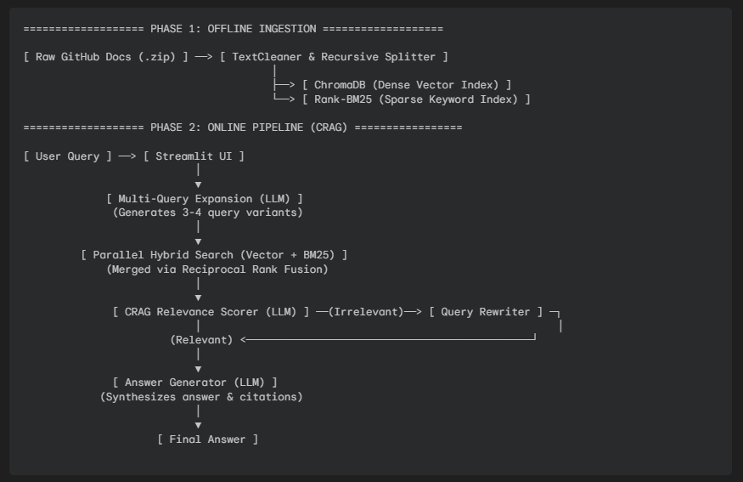

🚀: Future Enhancements & Extra Work
While DocuSense is currently an impressive, fully functional Advanced RAG pipeline, real-world software is never truly "finished." If you want to continue working on this project to learn new skills, or if an interviewer asks how you would scale it, here are the exact features you should focus on next.
1. Cloud Vector Databases (Saying Goodbye to Git LFS)
The Problem: Right now, your ChromaDB database is a 300MB+ SQLite file sitting in your GitHub repository using Git LFS. If you add 10 more libraries, it will grow to 2GB, which is expensive and slow to clone. The Extra Work: Migrate from local ChromaDB to a managed cloud vector database like Pinecone, Qdrant Cloud, or Weaviate.
- Why it looks good: It proves you know how to work with microservices and managed cloud infrastructure, rather than just local databases.
2. Automated Data Ingestion (CI/CD / MLOps)
The Problem: The documentation for LangChain and PyTorch updates every single week. Right now, your database has a "snapshot" of the docs from today. Over time, it will become outdated. The Extra Work: Create a GitHub Actions CRON job. Set up a script that runs every Sunday night at 2:00 AM, automatically scrapes the latest GitHub repos, checks for changes, updates the Vector/BM25 databases, and pushes the fresh data to your app.
- Why it looks good: This moves your project from "Data Engineering" into MLOps (Machine Learning Operations). Automation is highly valued in enterprise environments.
3. Streaming UI (The "ChatGPT" Effect)
The Problem: When a user asks a question, they sit staring at a spinning wheel for 10–20 seconds while the LLM generates the answer. The Extra Work: Implement Streaming Generation in your Streamlit app using LangChain's .astream() method. This will make the text appear on the screen word-by-word, exactly like ChatGPT.
- Why it looks good: It drastically improves the User Experience (UX) and shows you understand asynchronous web rendering and WebSockets.
4. Conversational Memory (Chat History)
The Problem: DocuSense is a Q&A bot, not a conversational bot. If you ask "What is a Random Forest?" and then follow up with "How do I evaluate it?", it will forget what "it" is. The Extra Work: Implement LangChain's RunnableWithMessageHistory to pass the last 5 chat messages into the prompt, giving the LLM short-term memory.
- Why it looks good: It bridges the gap between a search engine and a true AI Assistant.
5. Quantitative Evaluation (Ragas / TruLens)
The Problem: Right now, you know DocuSense works because you tested it manually. But how do you prove mathematically that Hybrid Search is 20% better than standard Vector Search? The Extra Work: Use a framework like Ragas or TruLens to quantitatively score your RAG pipeline based on metrics like Context Precision, Context Recall, and Answer Faithfulness.
- Why it looks good: Senior AI Engineers do not rely on "vibes" to know if a model is good; they use math and benchmarks. Bringing up quantitative evaluation in an interview is a guaranteed way to stand out.

And the link of the AI is : Link of the chat

